**LAB Report #4: Force Control of a Pneumatic Muscles using a Custom-Built Strain Gauge Load Cell**

Reporter: MINGSHAN HE (2022-24052, hemingshan@snu.ac.kr)

Instructor: Yong-Lae Park

Lab Assistant: Tae Hwa Hong, Sung Jin Kim

**Results**

1. Plot the result from the Test 1 and provide the calibration mapping.

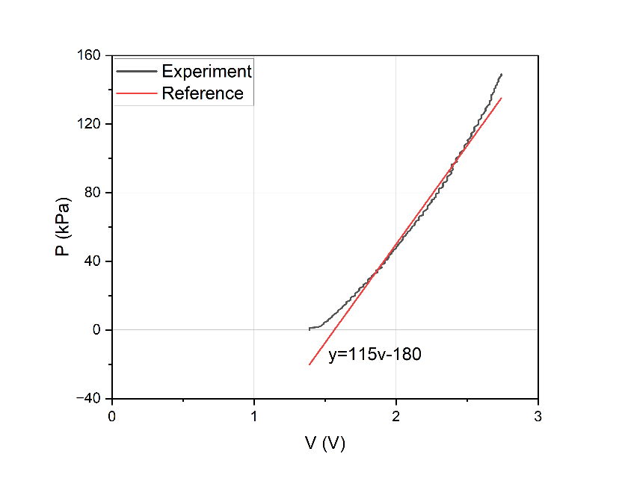

$$P_{in}=115*V_{load cell}+180$$

1. Provide step response plots for various gain parameters (P, PD, PID cases) and desired constant forces
   1. Each plot should be in Force (N) vs. Time (sec).
   2. Each plot should show a target force level, a response signal measured by the strain-gauge force sensor.

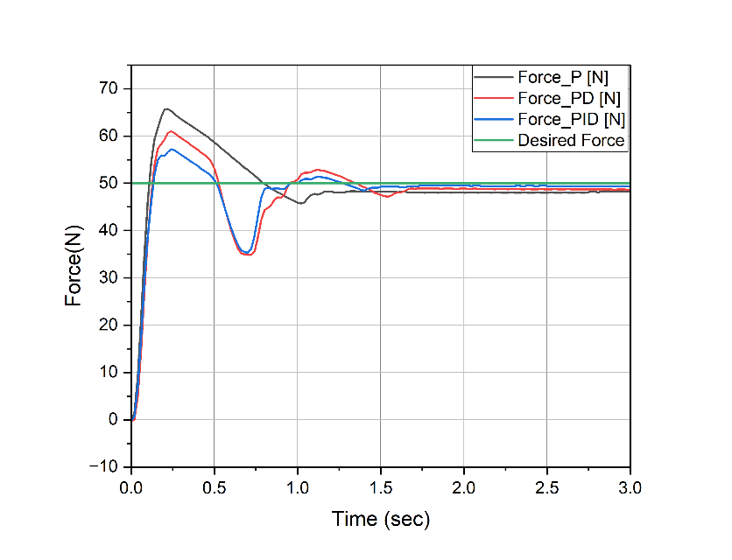

1. Plot the given force profile and the controlled force. Provide the error of the controlled signal and discuss whether the gains are correctly set.

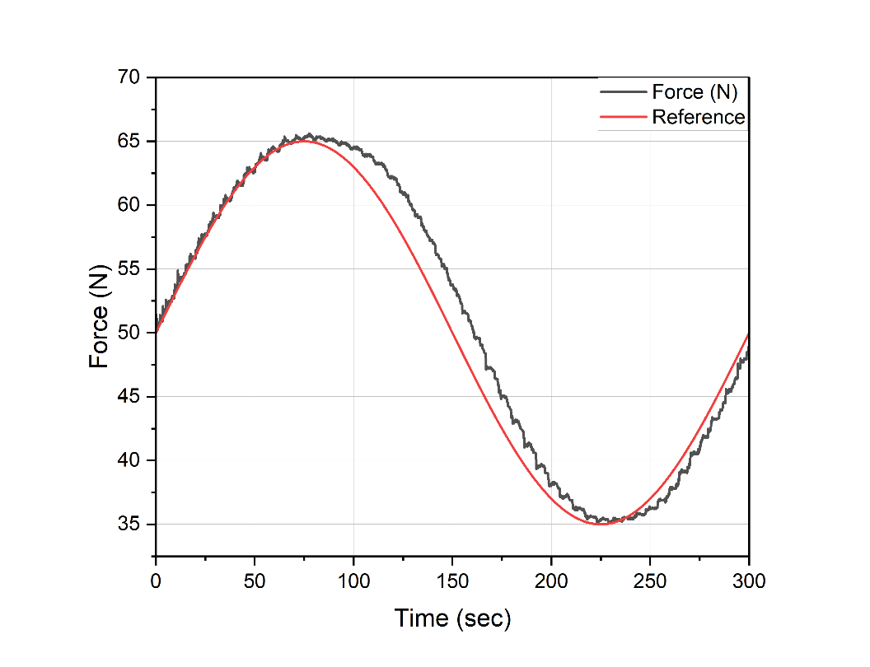

**Discussion**

1. Report and discuss the rise time, settling time, steady state error, and transient response characteristics for all cases in Test 2. Discuss the differences between the three cases.

|  |  |  |  |
| --- | --- | --- | --- |
| Controller Type | Rise Time(s) | Settling Time(s) | Steady State Error |
| P | 0.2 | 0.62 (5%); 1.35(2%) | 3.0% |
| PD | 0.24 | 0.8 (5%); 0.85(2%) | 2.1% |
| PID | 0.25 | 0.75(5%); 0.8(2%) | 1.0% |

First, P case has the small rise time, but the overshoot will cause the system not be accuracy. Thus PD case has the larger rise time, but it will decrease the overshoot. But it will cause the jitter after the rise time. The PID case has the same rise time, and a little of jitter, but it can decrease the state error clearly.

1. Can the characteristics of the actuator be observed based on the step responses (F-t curves we obtained)?

Yes. But it is some of the characteristics.

The main analysis tool is using the step responses. For the transient response, it always use the step signal and to get the data to discuss the characteristics. Thus I think the characteristics of the actuator can be observed. If it is needed, we could analysis the frequency characteristics of the actuator.

1. What advantages does closed-loop control provide over open-loop control? Are there any drawbacks?

The closed-loop control can track the reference signal closely. Because the closed loop is generated by the error. Thus the closed-loop control could eliminate the state error and provide the better dynamic response characteristics. It means the closed-loop control can reflect the more accurate performance by using the feedback. And it also can recover from external disruption or avoid damage.

But the close-loop control will have the jitter caused by error controlling. Although the open-loop control has less jitter than closed-loop, I think the other performances of the closed-loop control are better enough than the open one. And it may cost more than the open-loop control.

1. What elements can be added or substituted to the controller to improve it? How do these elements help the controller? (Hint: bang-bang controller, Lead-lag compensator, dynamics of the system, nonlinear control methods)

For the overshot, the bang-bang controller could decrease it in the setting range. But it will cause the shock or jitter in the setting range.

The lead-lag compensator is always used to improve the system parameters. But it need to analysis the system and design the appropriate parameters to reduce steady state error, resonant peak and improve system response.

For the nonlinear control methods, I am familiar with backstepping method, it could stabilize controls for a system.

And there are other methods, like Linear-Quadratic Regulator, Model Predictive Control, and H-Infinite Control. All of them are famous in the control algorithm, but I think the PID control is most stable and ensure the performance.

1. Are there scenarios in which a linear controller would not work for this type of artificial muscle? Would the system go unstable?

The artificial muscle is linear system, and a linear controller would work for it. If the artificial muscle has the load which will make the system be nonlinear. And then the linear controller may not work for the system, and the system also go unstable.